**Supplementary documents**

CLUSTAL O(1.2.4) multiple sequence alignment

BBD96102.1 MFHTGAGGNGYGDGNAGFHQHLQQSPVYVPSSRAVPHQYSPAAGTHFGAAAHQGGWAHAG 60

3VD6_3|Chain ------------------------------------------------------------ 0

BBD96102.1 GSYGDMASQAHGLGGAAHASPLSAGQFYTQNMVMSSWRAYDGSGFQRTSPYESAMEFQFG 120

3VD6_3|Chain ------------------------------------------------------------ 0

BBD96102.1 EGRECVNCGAISTPLWRRDGTGHYLCNACGLYHKMNGMNRPLIKPSKRLTATRRLGLCCT 180

3VD6_3|Chain EARECVNCGATATPLWRRDRTGHYLCNACGLYHKMNGQNRPLIRPKKRMIVSKRAGTQCT 60

*.******** :******* ***************** *****:*.**: .::* * **

BBD96102.1 NCGTRTTTLWRRNNDGEPVCNACGLYFKLHGVNRPLAMRKDGIQTRKRKPKKQGGGSGER 240

3VD6_3|Chain NCQTTTTTLWRRNASGDPVCNACGLYFKLHQVNRPLTMRKDGIQTRNRKASGKGKKKRG- 119

** * ******** .*:************* *****:*********:** . :* .

BBD96102.1 DDSSSTSVEDGKTPVSISNQQQHSNQQVPSSSQNHPNHQHSPDNKVTQTLERPYLSPASL 300

3VD6_3|Chain ------------------------------------------------------------ 119

BBD96102.1 LPSSSSLVKSEPGYDYSCLQNQGYPYQQIFGFPGAGPTNPELAYHHQHHVTASAKLMATT 360

3VD6_3|Chain ------------------------------------------------------------ 119

Figure S1: Alignment of Pannier and 3VD6 in CLUSTAL format with base/residue numbering.

**C**

**B**

**A**

Figure S2: (a) Alphafold structure of Pannier, (b) 3VD6 structure and (c) superimposed structures of 3VD6 and Pannier.

**A**

**B**

Figure S3: (a) showing the elytral pattern with a low diffusion rate.

(b) showing the elytral pattern with a high diffusion rate.

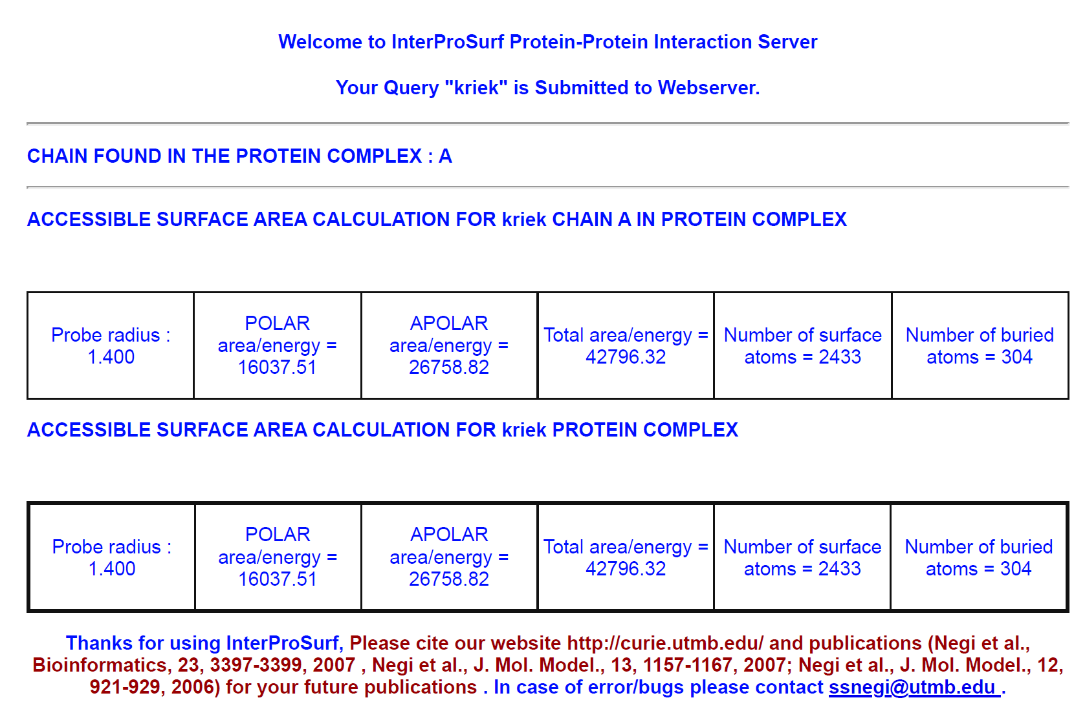

Figure S4: Possible protein-protein interaction sites on the Pannier protein, determined using InterProSurf .

|  |  |
| --- | --- |
| Gene names | Gene ID |
| *Henna* | 123682245 |
| *ple* | 123673805 |
| *Ddc* | 123679005 |
| *tan* | 123674268 |
| *y (yellow)* | 123676132 |
| *laccase* | 123676796 |
| *GTP cyclohydrolase* | 123679556 |
| *ebony* | 123680340 |
| *NinaB* | 123671684 |

Table S1: List of all genes involved in melanin synthesis in *H. axyridis.*